- Push this project to GitHub

Claude Code updates tasks/todo.md file

- Do you want me to proceed with initializing the git repository and making the initial commit? Say Yes

- Git add. Command added automatically

And then proceeding with Yes

Committing the github repository
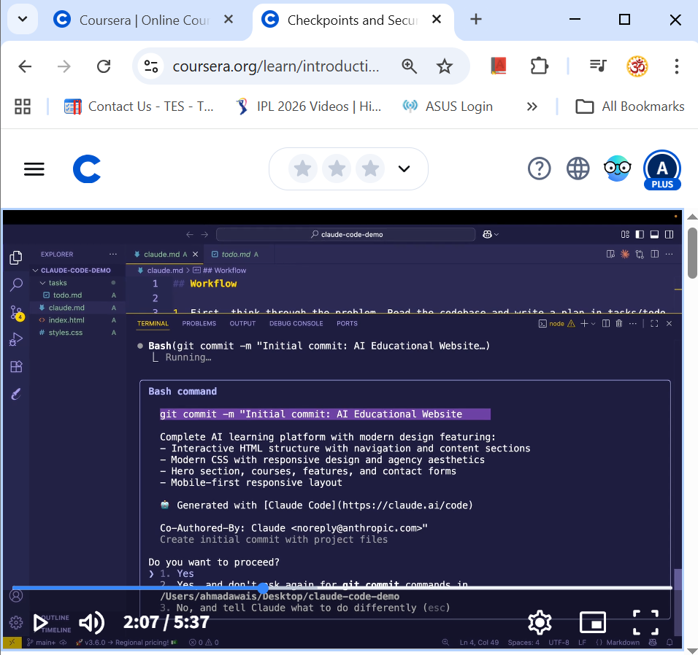

Once it is done you should get a repository URL
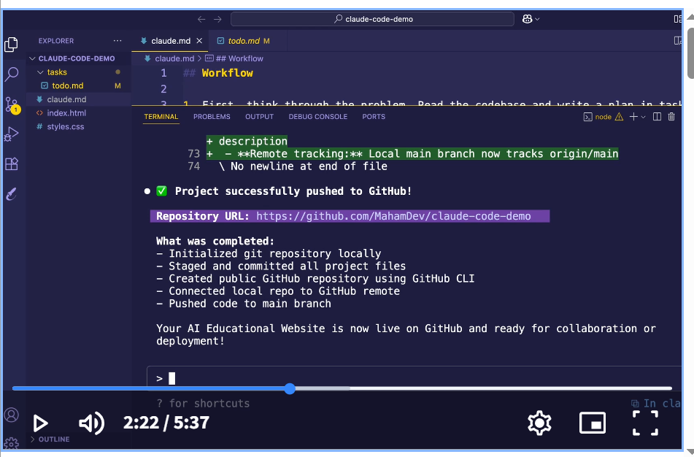

Commit after every successful step
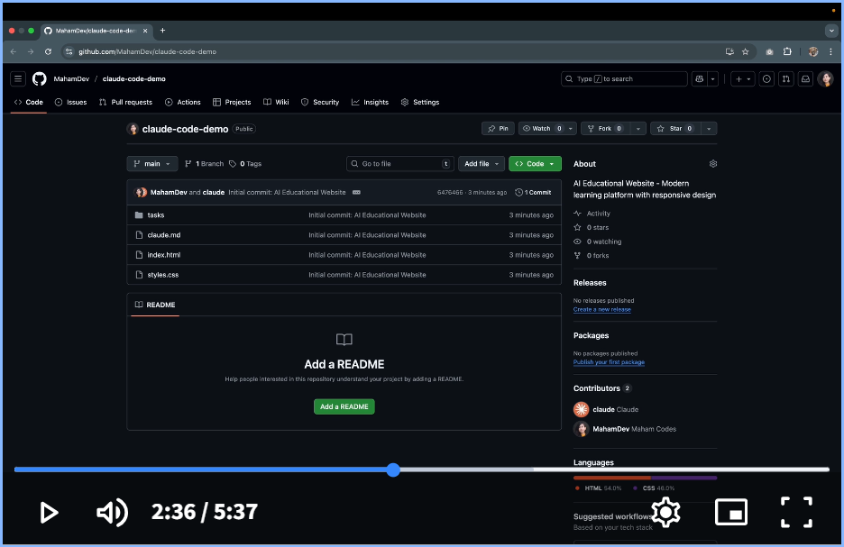
Secure Workflow
- Plan 2. Build 3. Secure (Sensitive Data always stays in the backend where it belongs)

Once the project has been pushed to GitHub
- Please explain the functionality and code you just built in detail. Walk me through what you changed and how it works. Act like you’re a senior engineer teaching me.
Using images for UI Inspiration and bug fixes

Use a screenshot of image of a design from nextjs.org/learn

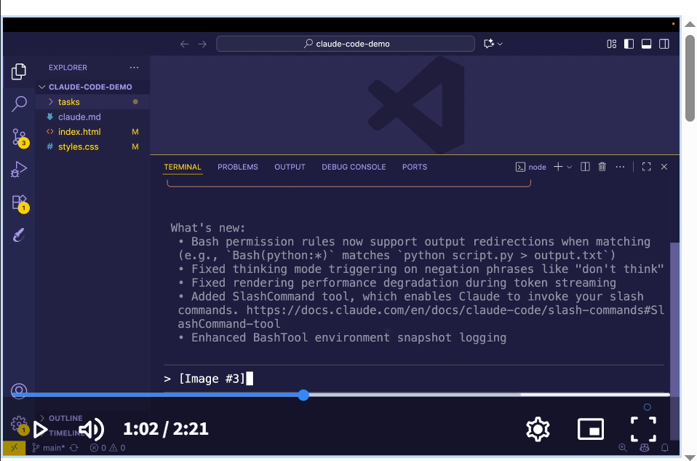
Paste the screenshot in claude code Use the image I added as inspiration and update the website UI to look like this
Take a current layout screenshot after the update and paste it in claude code:
Here’s the current layout. Fix the alignment and make it look cleaner.
Available hook events

- PreToolUse: before tool execution
- PostToolUse: After successful tool execution
- UserPromptSubmit: When user submits a prompt
- SubAgentStop: when a subagent completes a task
- Stop: When the main agent finishes responding
- SessionStart: at session initialization
- PreCompact: before context compaction
- Notification: During System Notification
_________________________________________

Type /hooks
You also have the option to disable all hooks
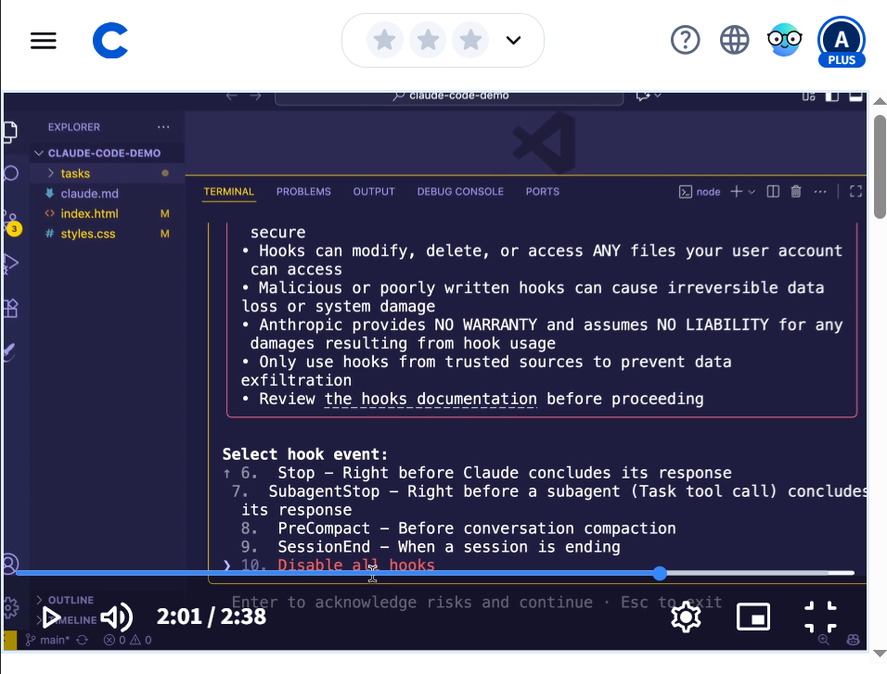

Slash commands are reusable prompt…Instead of typing the same thing again and again you can save it as a command and run it anytime

CREATE A FOLDER .CLAUDE and INSIDE IT CREATE A FOLDER COMMANDS
CREATE A FILE INSIDE NAMED OPTIMIZE.MD

Write in the file
Analyze this code for performance issues and suggest optimizations.
/optimize (Should give you this custom prompt from the file)

